IPV6 Address Lab
Topology
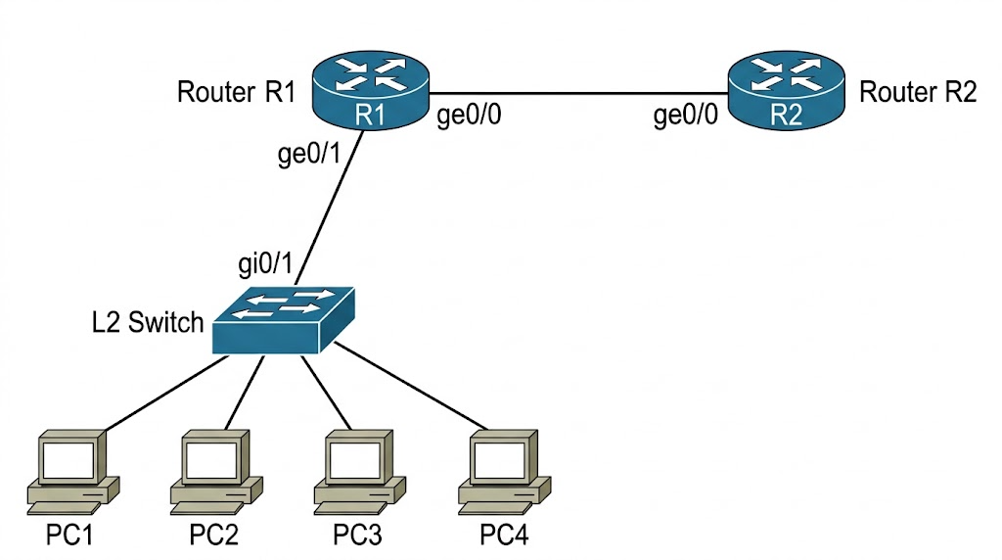
IP address details
R1 GE0/1- 2001:db8:acad:1::1/64
R1 Ge0/0-2001:db8:acad:2::1/64

1.Configure R1 LAN interface to the switch
R1(config)# interface GigabitEthernet0/1
ipv6 address 2001:db8:acad:1::1/64
ipv6 enable
no shutdown
exit
2. Configure R1 interface to R2
R1(config)# interface GigabitEthernet0/0
ipv6 address 2001:db8:acad:2::1/64
ipv6 enable
no shutdown
exit

3.Configure R2 as a SLAAC Client
R2> enable
R2# configure terminal
R2(config)# interface GigabitEthernet0/0
ipv6 enable
ipv6 address autoconfig
no shutdown

Enable IPv6 Routing on R1
R1> enable
R1# configure terminal
R1(config)# ipv6 unicast-routing

Verification command
R2# show ipv6 interface brief

NOTE: In IPv6 networking, RA stands for Router Advertisement.
It is a multicast ICMPv6 message (Type 134) sent by a router to announce its presence on a local network. RAs provide connected devices with critical configuration information, including the network prefix, the default gateway address, and specific flags that instruct the device on whether to use SLAAC or DHCPv6 to configure its own IP address.

